LAB EXAM

MS.Net Technologies

Total Marks: 20 Time: 2 hours

1. Write a program in C# Sharp to show how the three parts of a query operation execute.

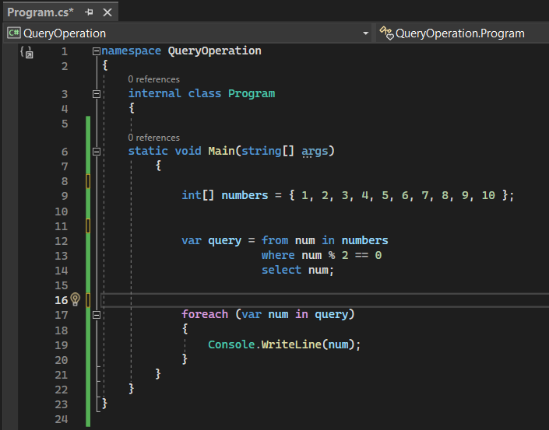

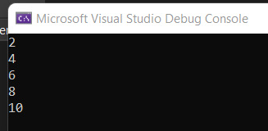

2. Create a model class called Product. Add an Index and by using model binding, perform create,

update and delete operations for Product details such as ProductId, ProductName, and price.



         